**ASSIGNMENT – 5**

**INFORMATION MANAGEMENT**

NAME: JAHNAVI ANGATI (ja54632), KARTHICK VEL KATHIRVEL (kk37347)

Due Date: 11-05-2023

**Goal:**

A hand on experience with Kubernetes to complete as a homework to learn the basics of Kubernetes with an interactive tutorial.

**Provider:**

Kubernetes (Official Kubernetes Website)

**Duration:**

Self-paced, typically 3 hours

**Link:**

https://kubernetes.io/docs/tutorials/stateless-application/hello-minikube/

**Instructions:**

1. Set up a local Kubernetes cluster using Minikube.
2. In the website's Tutorial tab, go through the 'Hello Minikube'
3. In the Tutorial tab's 'Learn Kubernetes Basics' go through the

* 'Create a Cluster'
* 'Deploy an App'
* 'Explore your app'
* 'Expose your App'
* 'Scale your App'

1. Obtain screenshots showing that each step above is done, paste into a file and upload the file.
2. **Set up a local Kubernetes cluster using Minikube**

*minikube dashboard*

1. **Hello Minikube: 'Create a Cluster'**

*kubectl create deployment hello-node --image=registry.k8s.io/e2e-test images/agnhost:2.39 -- /agnhost netexec --http-port=8080*

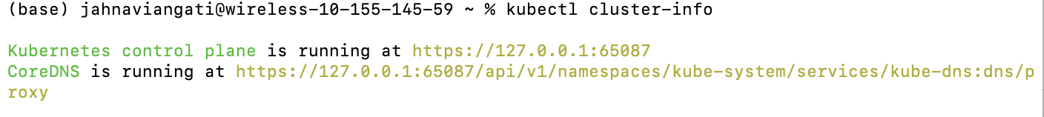

*kubectl expose deployment hello-node --type=LoadBalancer --port=8080*

*minikube addons list*

*minikube addons enable metrics-server*



View the Pod and Service created by installing that addon:

1. **Deploy an App**

*kubectl create deployment kubernetes-bootcamp --image=gcr.io/google-samples/kubernetes-bootcamp:v1*

*export POD_NAME=$(kubectl get pods -o go-template --template '{{range .items}}{{.metadata.name}}{{"\n"}}{{end}}')*

*echo Name of the Pod: $POD_NAME*



*kubectl get nodes*

**

1. **Explore your App**

*kubectl get pods*

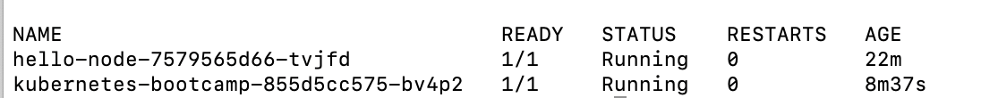

*kubectl describe pods*

1. **Expose your App Publicly**

We have now a running Service called kubernetes-bootcamp. Here we see that the Service received a unique cluster-IP, an internal port and an external-IP (the IP of the Node).

*kubectl describe services/kubernetes-bootcamp*

1. **Scale your App**

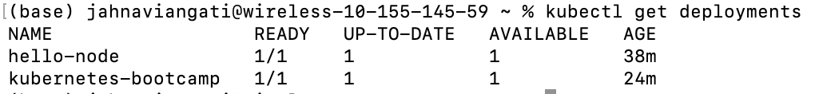

* NAME lists the names of the Deployments in the cluster.
* READY shows the ratio of CURRENT/DESIRED replicas
* UP-TO-DATE displays the number of replicas that have been updated to achieve the desired state.
* AVAILABLE displays how many replicas of the application are available to your users.
* AGE displays the amount of time that the application has been running.

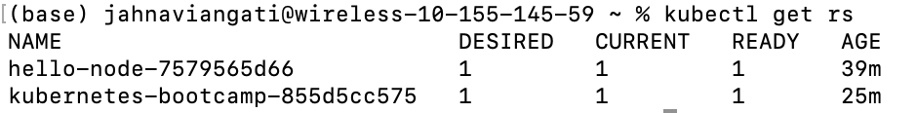

Let’s scale the Deployment to 4 replicas. We’ll use the kubectl scale command, followed by the Deployment type, name and desired number of instances:

Checking if the pods have changed:

1. **Update your App**

To update the image of the application to version 2, use the set image subcommand, followed by the deployment name and the new image version:

Verifying the Update:



Rollback an update:

Cleaning up local cluster:

